Suman Paudel (33)

Assignment II

# Lab 2:

**Prepare Lab Sheet of MYSQL Statements for following.**

1. Insert at least 5 tuples in each of the tables of the Yourname_Roll_COMPANY database in LAB-1.

**SQL Script**:

**For Office Table:**

**INSERT** **INTO** ***Office*** (***Onumber***, ***Oname***, ***Country***) **VALUES** (1, **'Suman_Office_33'**, **'Nepal'**);

**INSERT** **INTO** ***Office*** (***Onumber***, ***Oname***, ***Country***)

**VALUES**

(2, **'Suman_Ncell_33'**, **'Nepal'**),

(3, **'Prabhat Ale'**, **'USA'**),

(4, **'Anish Thapaliya'**, **'India'**),

(5, **'Gaurav Pandey'**, **'Japan'**);

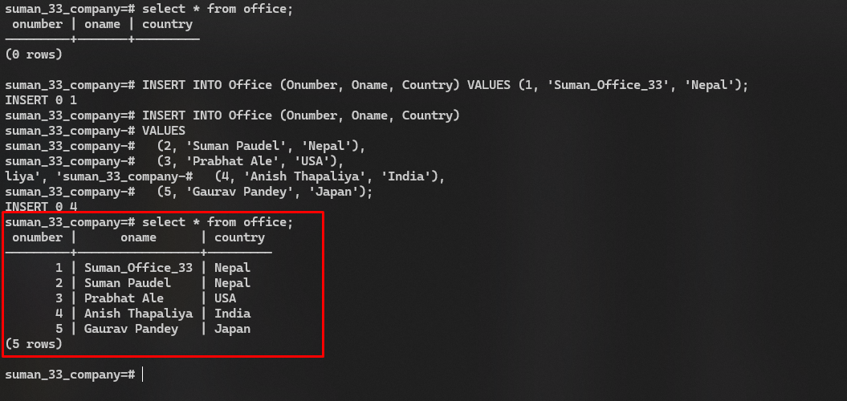**Output:**

**For Employee Table:**

**INSERT** **INTO** ***employee*** (***SSN***, ***Ename***, ***Gender***, ***Bdate***, ***Address***, ***SALARY***, ***Ono***, ***Years_of_experience***)

**VALUES** (33, **'Suman Paudel'**, **'M'**, **'1997-10-22'**, **'Kathmanu, Nepal'**, 30000.00, 1, 3);

**INSERT** **INTO** ***employee*** (***SSN***, ***Ename***, ***Gender***, ***Bdate***, ***Address***, ***SALARY***, ***Ono***, ***Years_of_experience***)

**VALUES**

(1, **'Rekha Thapa'**, **'F'**, **'1992-03-22'**, **'Kathmandu, Nepal'**, 55000.00, 2, 5),

(2, **'KP Oli'**, **'M'**, **'1978-11-08'**, **'Bhaktapur, Nepal'**, 72000.00, 3, 2),

(3, **'Puspa Kamal Dahal Pracanda'**, **'M'**, **'1990-09-01'**, **'Lalitpur, Nepal'**, 48000.00, 4, 3),

(4, **'Rabi Lamichane'**, **'M'**, **'1983-04-30'**, **'Chitwan, Nepal'**, 60000.00, 4, 7);

**Output:**

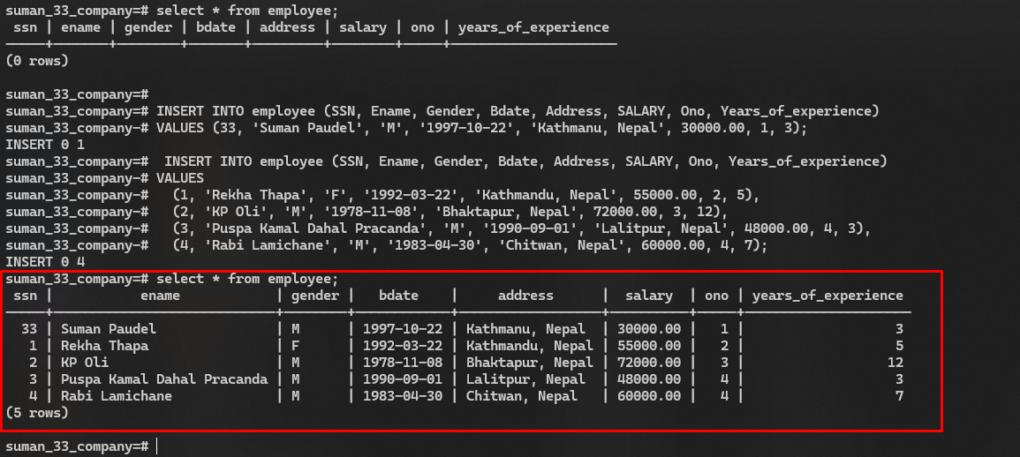

**For Project Table:**

**INSERT** **INTO** ***Project*** (***Pnumber***, ***Pname***, ***Plocation***, ***Onumber***)

**VALUES** (66, **'Suman_ProjMDS'**, **'Kathmandu'**, 1);

**INSERT** **INTO** ***Project*** (***Pnumber***, ***Pname***, ***Plocation***, ***Onumber***)

**VALUES**

(2, **'Project Kathmandu'**, **'Kathmandu'**, 2),

(3, **'Project Butwal'**, **'Butwal'**, 3),

(4, **'Project Chitwan'**, **'Chitwan'**, 4),

(5, **'Project Dhangadi'**, **'Dhangadi'**, 5);

**Output:**

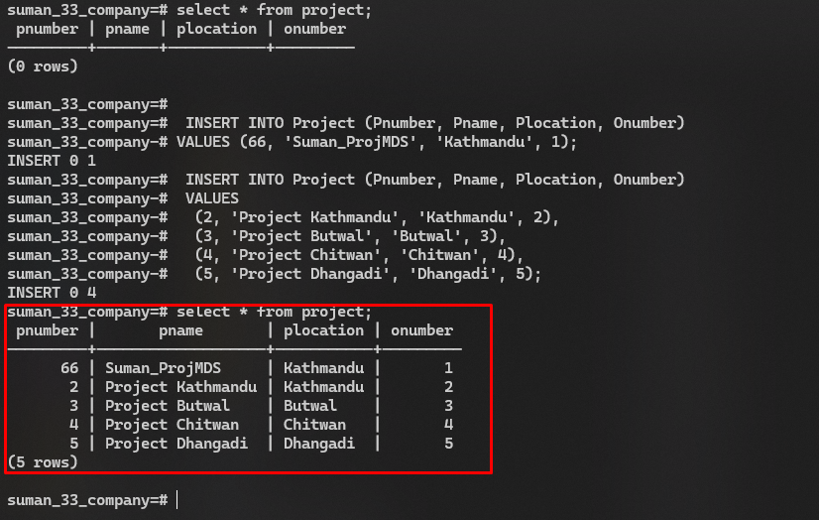

**For Works_on Table:**

**INSERT** **INTO** ***Works_on*** (***ESSN***, ***Pno***)

**VALUES** (33, 66);

**INSERT** **INTO** ***Works_on*** (***ESSN***, ***Pno***)

**VALUES**

(1, 2),

(2, 3),

(3, 4),

(4, 5);

**Output:**

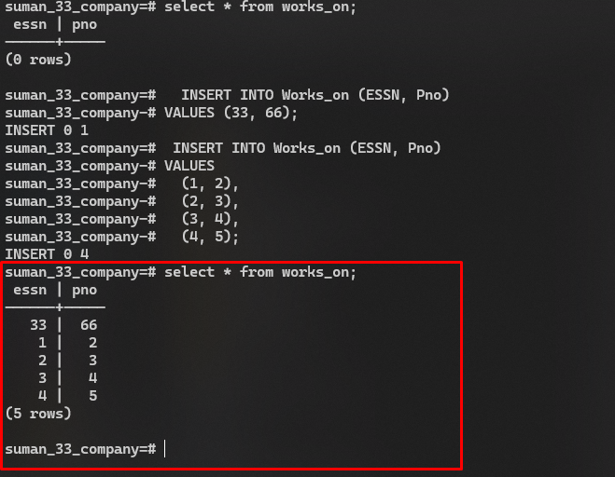

**For Employee Table:**

**INSERT** **INTO** ***Dependents*** (***Did***, ***Dname***, ***Dage***, ***SSN***, ***Drelation***)

**VALUES** (1, **'Pushpa Panta Jaisi'**, 13, 33, **'Mother'**);

**INSERT** **INTO** ***Dependents*** (***Did***, ***Dname***, ***Dage***, ***SSN***, ***Drelation***)

**VALUES** (2, **'Krishna Prasad Jaishi'**, 13, 33, **'Father'**),

(3, **'Silu Poudel'**, 12, 33, **'Sister'**),

(4, **'Sujita Sharma'**, 9, 33, **'Cousin Sister'**),

(5, **'Prabin Adhikari'**, 14, 33, **'Cousin Brother'**);

**Output:**

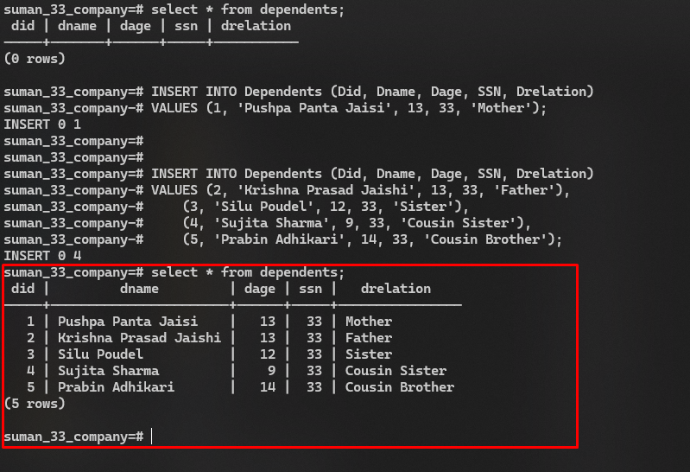

1. In the database Yourname_Roll_COMPANY in LAB-1, Create a table PF(PFID, SSN, PFCategoryName, Amount, Start_date, Remarks); where SSN is foreign key referencing Employee. The start date should be of date type.

**SQL Script:**

**create** **table** PF(

PFID **int** **primary** **key**,

SSN **int**,

PFCategoryName **varchar**(40),

Amount **numeric**,

Start_date **date**,

Remarks **text**,

**constraint** fk_pf **foreign** **key**(SSN) **references** Employee(SSN)

);

**Output:**

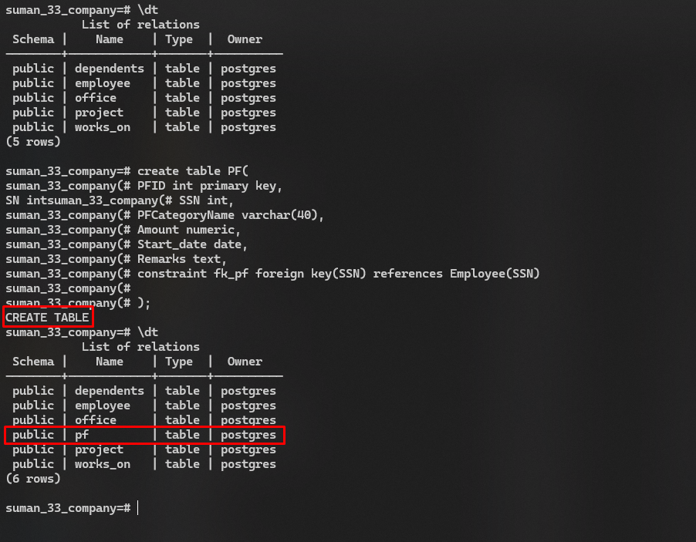

1. In the database Yourname_Roll_COMPANY in LAB-1, alter the table Employee and add an attribute Matrital_status of type varchar. Update the records in the table and set values of status to “Married”, “Single”, “Divorced”. At least three records should have status married.

**SQL Script:**

**ALTER** **table** employee **add** **column** marital_status **varchar**(20);

**Updating Part:**

**update** ***employee*** **set** ***marital_status*** = **'Single'** **WHERE** ***ssn*** = 33;

**update** ***employee*** **set** ***marital_status*** = **'Married'** **WHERE** ***ssn*** = 1;

**update** ***employee*** **set** ***marital_status*** = **'Married'** **WHERE** ***ssn*** = 2;

**update** ***employee*** **set** ***marital_status*** = **'Married'** **WHERE** ***ssn*** = 3;

**update** ***employee*** **set** ***marital_status*** = **'Divorced'** **WHERE** ***ssn*** = 4;

**Output:**

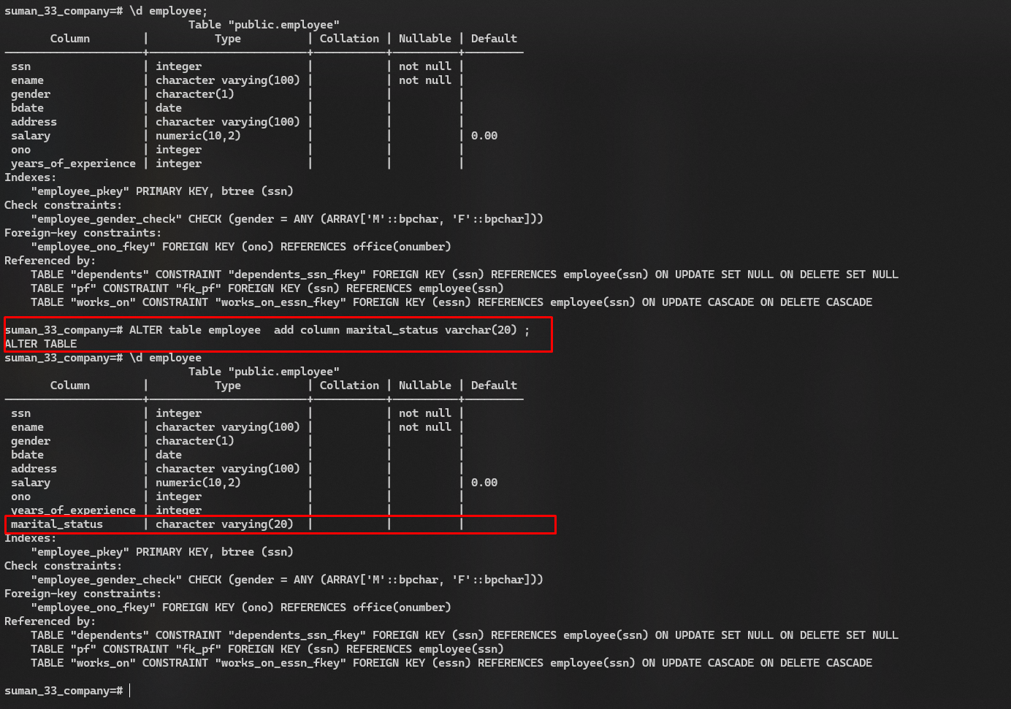**Alter Part**

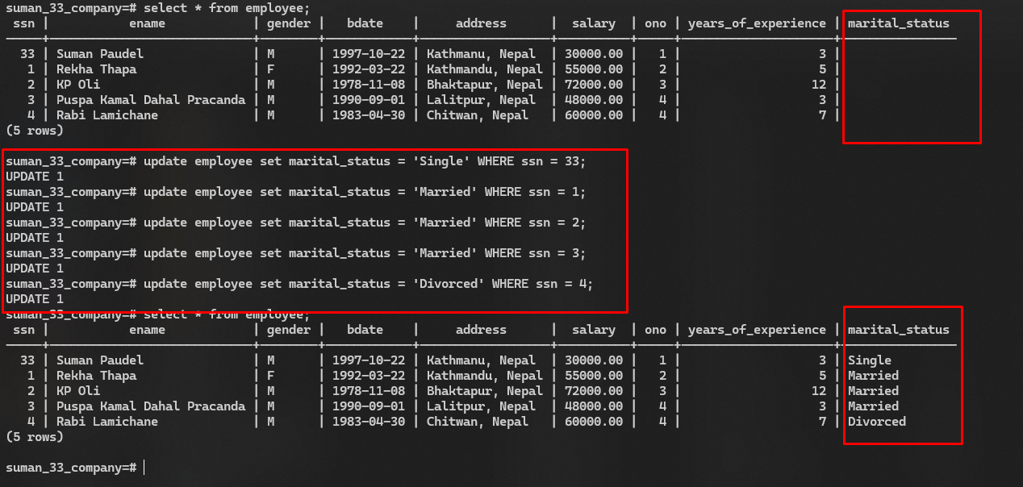**Updating Part**

1. Insert ten records in the table PF, where at least two records have the Remarks field NULL.

**SQL Script:**

**INSERT** **INTO** ***pf*** (***PFID***, ***SSN***, ***PFCategoryName***, ***Amount***, ***Start_date***, ***Remarks***) **VALUES**

(1, 33, **'Retirement'**, 5000.00, **'2022-01-01'**, **'Regular contribution'**),

(2, 1, **'Medical'**, 2000.00, **'2022-02-15'**, **'Health insurance'**),

(3, 2, **'Education'**, 3000.00, **'2022-03-01'**, **'Child education fund'**),

(4, 3, **'Retirement'**, 1600.00, **'2022-04-01'**, **'Additional contribution'**),

(5, 4, **'Housing'**, 4000.00, **'2022-05-01'**, **NULL**),

(6, 33, **'Retirement'**, 550.00, **'2022-06-01'**, **'Regular contribution'**),

(7, 1, **'Medical'**, 2500.00, **'2022-07-01'**, **'Dental insurance'**),

(8, 2, **'Education'**, 3500.00, **'2022-08-01'**, **'Child tuition'**),

(9, 3, **'Retirement'**, 6500.00, **'2022-09-01'**, **'Additional contribution'**),

(10, 4, **'Housing'**, 4500.00, **'2022-10-01'**, **NULL**);

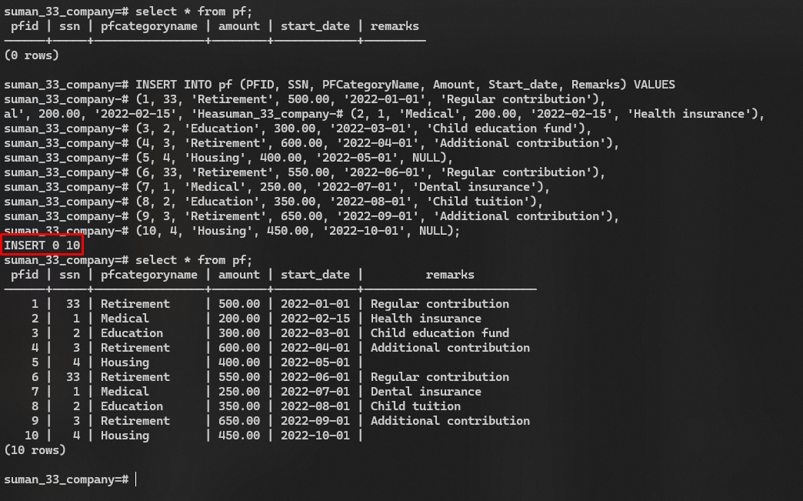**SQL Script:**

1. Select all employees.

**SQL Script:**

**SELECT** * **from** ***employee*** ;

**Output:**

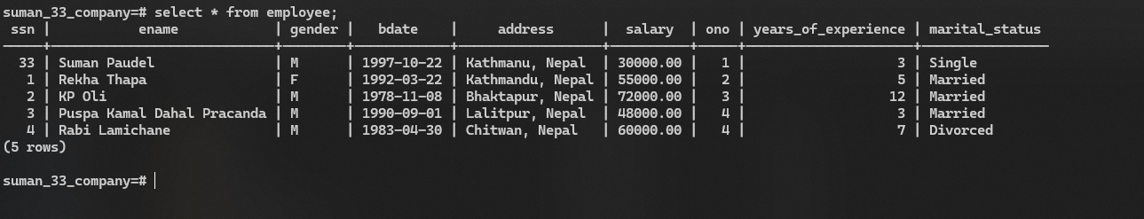

1. Select employees having salary greater than 30000 and list the results in descending order of Ename.

**SQL Script:**

**SELECT** * **from** ***employee*** **where** ***salary*** > 30000 **order** **by** ***ename*** **desc**;

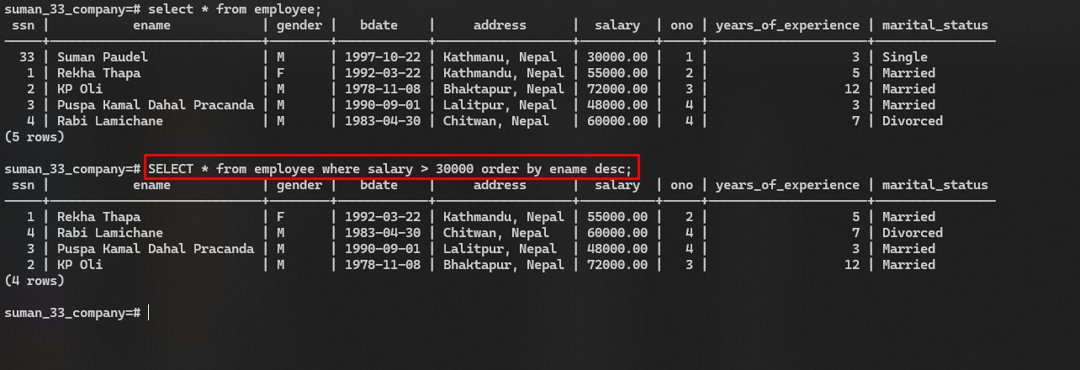**Output:**

1. Retrieve the tuples from project table. Sort the tuples on the basis of Pname.

**SQL Script:**

**SELECT** * **from** ***project*** **order** **by** ***pname***;

**Output:**

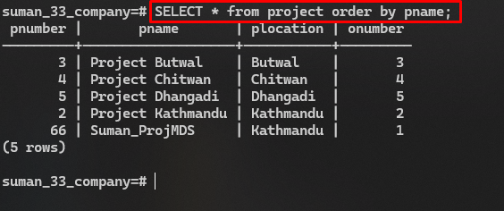

1. Select the employees having salary greater than 30000 and years of experience less than 3 years.

**SQL Script:**

**SELECT** * **from** ***employee*** **WHERE** ***salary*** > 30000 **and** ***years_of_experience*** < 3;

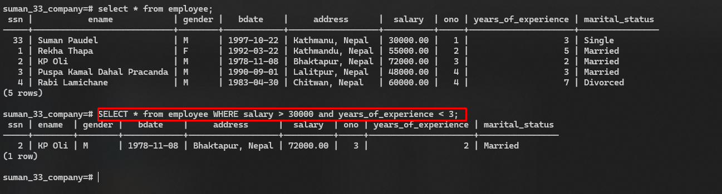**Output:**

1. Select the name, address, and salary of employees having salary greater than 30000 or years of experience less than 3 years.

**SQL Script:**

**SELECT** ***ename***, ***address***, ***salary*** **from** ***employee*** **WHERE** ***salary*** > 30000 **OR** ***years_of_experience*** < 3;

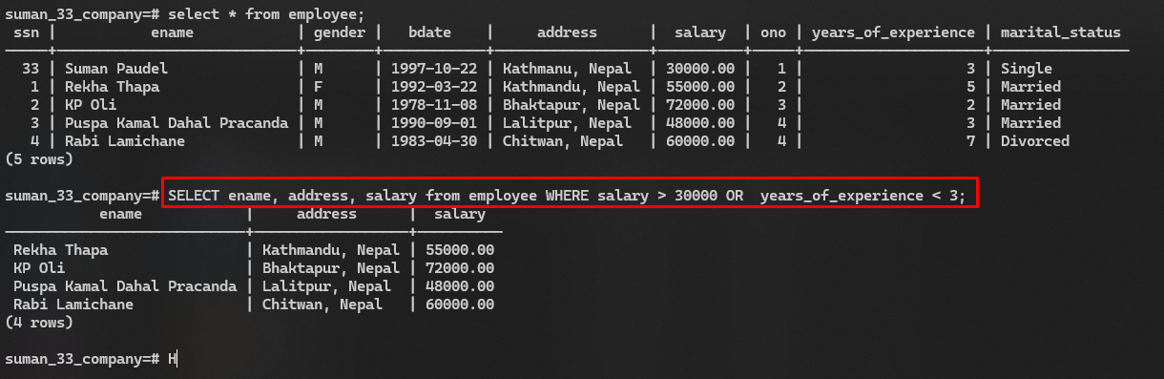**Output:**

1. Select the all dependents.

**SQL Script:**

**select** * **from** ***dependents***;

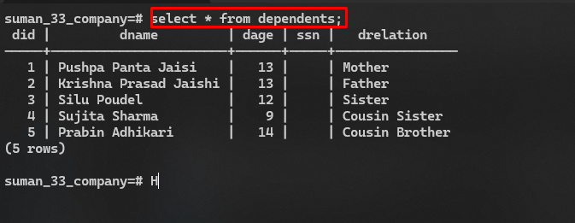**Output:**

1. Select the name and age of the dependents having age between 5 to 60.

**SQL Script:**

**select** ***dname***, ***dage*** **from** ***dependents*** **where** ***dage*** **between** 5 **and** 60;

**Output:**

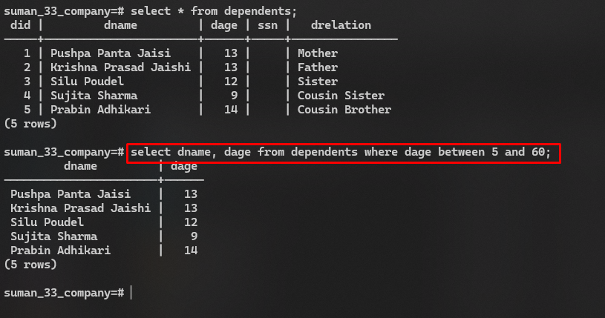

1. Select the offices having office name like “%Nt%” as substring.

**SQL Script:**

**select** * **from** ***office*** **WHERE** ***oname*** **like** **'%Nt%'**;

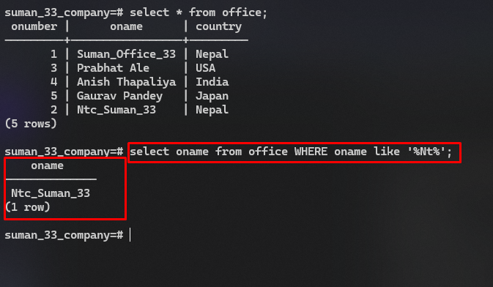**Output:**

1. Select the offices having office number in (1, 2, 3).

**SQL Script:**

**select** ***onumber*** **from** ***office*** **where** ***onumber*** **in** (1,2,3);

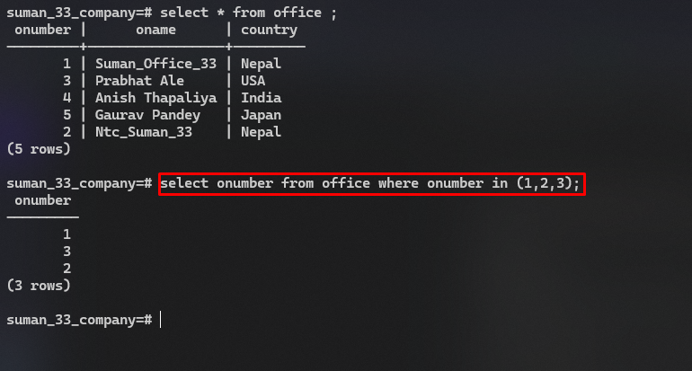**Output:**

1. Select the records from PF table where remarks is NULL.

**SQL Script:**

**select** * **from** ***pf*** **WHERE** ***remarks*** **is** **null**;

**Output:**

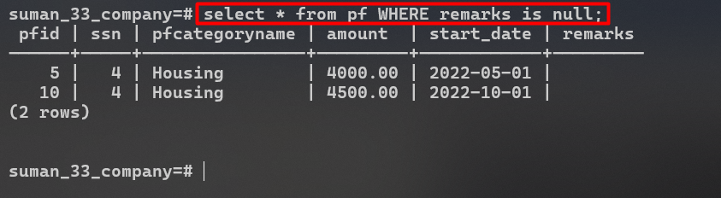

1. Select PF category name, amount, start date and remarks from PF where remarks is not NULL.

**SQL Script:**

**SELECT** ***pfcategoryname***, ***amount***, ***start_date***, ***remarks*** **from** ***pf*** **where** ***remarks*** **is** **not** **null**;

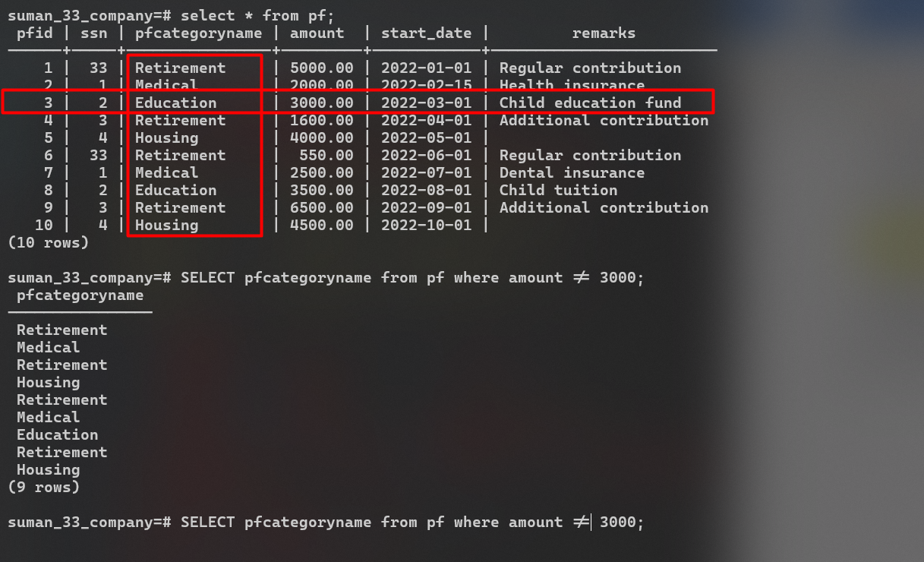**Output:**

1. Select the five records from PF table using LIMIT Clause.

**SQL Script:**

**select** * **from** ***pf*** **limit** 5;

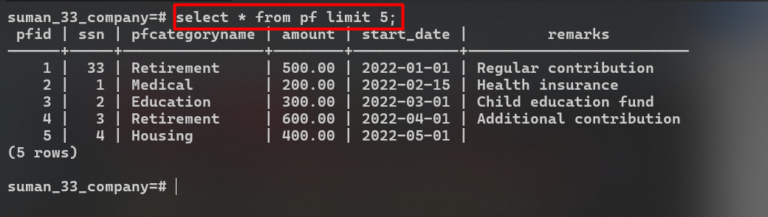**Output:**

1. Select the category name of PF where amount is not equal to 3000.

**SQL Script:**

**SELECT** ***pfcategoryname*** **from** ***pf*** **where** ***amount*** != 3000;

**Output:**

1. Select all employees who works on project no 2.

**SQL Script:**

**select** *e*.***ename*** **from** ***employee*** *e* **inner** **join** ***works_on*** *w* **on** *e*.***ssn*** = *w*.***essn*** **inner** **JOIN** ***project*** *p* **on** *p*.***pnumber*** = *w*.***pno*** **where** *p*.***pnumber***=2;

**Output:**

